|  |  |  |  |
| --- | --- | --- | --- |
| T90 |  | Control | Ultr |
| Lactate | weight | 0.645 | 0.645 |
|  | Length | 0.788 | 0.788 |
|  | Pvalue | 0.1323 | 0.1323 |
|  |  |  |  |
| Glucose | Weight | 0.3522 | 0.946 |
|  | Length | 0.0963 | 0.404 |
|  | Pvalue | 2.292e-06 | 0.1076 |
|  |  |  |  |
| Cortisol | weight | 0.120 | 0.153 |
|  | Length | 0.292 | 0.117 |
|  | Pvalue | 0.141 | 0.2797 |
|  |  |  |  |
| RBC | weight | 0.0447 * | 0.573 |
|  | Length | 0.1450 | 0.999 |
|  | Pvalue | 0.05507 | 0.2846 |
|  |  |  |  |
| wbc | weight | 0.792 | 0.888 |
|  | Length | 0.989 | 0.744 |
|  | Pvalue | 0.7554 | 0.4454 |
|  |  |  |  |
| Thrombocytes | weight | 0.38674 | 0.0668 . |
|  | Length | 0.01484 * | 0.3282 |
|  | Pvalue | 0.0004858 | 0.02675 |
|  |  |  |  |
| K | weight | 0.1370 | 0.3274 |
|  | Length | 0.0973 | 0.2460 |
|  | Pvalue | 0.2361 | 0.4706 |
|  |  |  |  |
| CL | weight | 0.379 | 0.349 |
|  | Length | 0.487 | 0.825 |
|  | Pvalue | 0.6216 | 0.1276 |
|  |  |  |  |
| Na | weight | 0.308 | 0.00555 ** |
|  | Length | 0.254 | 0.05054 . |
|  | Pvalue | 0.5044 | 0.003356 |
|  |  |  |  |
|  |  |  |  |
|  |  |  |  |
|  |  |  |  |
|  |  |  |  |
|  |  |  |  |
|  |  |  |  |

**Chapter 3 - Result and discussion**

This study assessed the effects of Ultrasound on the growth performance and tissues of the European Seabass. Exposure to stressors affects the fish ability to facilitate metabolism leading to shortage in energy for growth, reproduction and other body development. The experimental fish was assessed for the growth performance of the control and treatment cages during the experimental period. Performance index like mean weight gain, percent weight gain, specific growth ration (SGR), Fulton condition factor (FCF) and the Hepatosomatic index (HSI) were calculated as shown in table 1.

Table 1: Growth performance of European seabass (*Dicentrarchus labrax*) for control and treatment

|  |  |  |  |  |
| --- | --- | --- | --- | --- |
| **CAGE** | **WEIGHT(g)** | **LENGTH (cm)** | **SGR** | **HSI** |
| Ultrasound | 94.92 | 6.86 | 1.12 | 2.89 |
| Control | 78.11 | 6.24 | 1.12 | 2.49 |

Table 2: Growth performance of the control and treatment by cage

|  |  |  |  |  |
| --- | --- | --- | --- | --- |
| **CAGE** | **WEIGHT (g)** | **LENGTH (cm)** | **SGR** | **HSI** |
| A1 | 57.49 | 5.55 | 1.08 | 2.47 |
| A3 | 87.55 | 16.65 | 1.18 | 3.78 |
| A8 | 98.73 | 6.92 | 1.14 | 2.50 |
| A13 | 102.3 | 6.59 | 1.07 | 3.08 |

**Weight gain**

Table 3: Weight gain per cage of European seabass (*Dicentrarchus labrax*) for control and treatment

|  |  |  |  |  |
| --- | --- | --- | --- | --- |
|  | A1 | A3 | A8 | A13 |
| Initial weight(g) | 35.1±1.85 | 46±2.56 | 55.2±2.76 | 63.5±3.06 |
| Final weight(g) | 92.59±3.29 | 133.55±6.77 | 153.93±6.69 | 165.80±6.86 |
| Weight gain(g) | 57.49 | 87.55 | 98.73 | 102.30 |
| Percentage weight gain (%) | 163.79 | 190.32 | 178.86 | 161.10 |

In the table above, the initial mean weight represents the mean weight in T0 while the final mean weight represents weights in T90. The initial mean weights for cage A1, A3, A8 and A13 are 35.1±1.85g, 46±2.56g, 55.2±2.76g and 63.5±3.06g respectively. The final mean weight for A1, A3, A8 and A13 are 92.59±3.29g, 46±2.56g, 55.2±2.76g and 63.5±3.06g respectively. The weight gain for fish in the ultrasound cage was 94.92g while the weight gain and percentage weight gain for fish in the control was 78.11g. When assessed per cage, A13 pooled the highest mean weight gain of 102.3g per fish which was followed by cage A8 (98.73g), A3 (87.55g) and A1 (57.49g). Similarly, percentage weight gain per cage shows a higher percentage in A3 (190.32 %) which was followed by A8, A1 and A13 at 178.86%, 163.79% and 161.10% respectively.

Figure 2 and 3 shows the boxplot for the final weight across cages (control and treatment) in T0 and T90 respectively. The boxplot for T0 shows unequal means among the cages. The highest mean weight range was found in cage A13 while the lowest mean weight range was found in cage A1. Also, there were higher variability in the mean weights of cage A13 and A3 than in cage A1 and A8. An ANOVA test showed that there are significant differences among the cages while a Tukey post-hoc test revealed that the difference lies among all cages except between cages A8 and A13. Figure.2 shows the boxplot for T90 with unequal means across the cages. The weights were more consistent in cage A3 but showed more variability in A13 than any other cage while the lowest mean range was found in cage A1. In the ANOVA test performed, there was sufficient evidence to say that the mean weights of the cages are equal (p<0.05). A post-hoc Tukey test revealed that the cages are only statistically similar between cages A8 and A13.

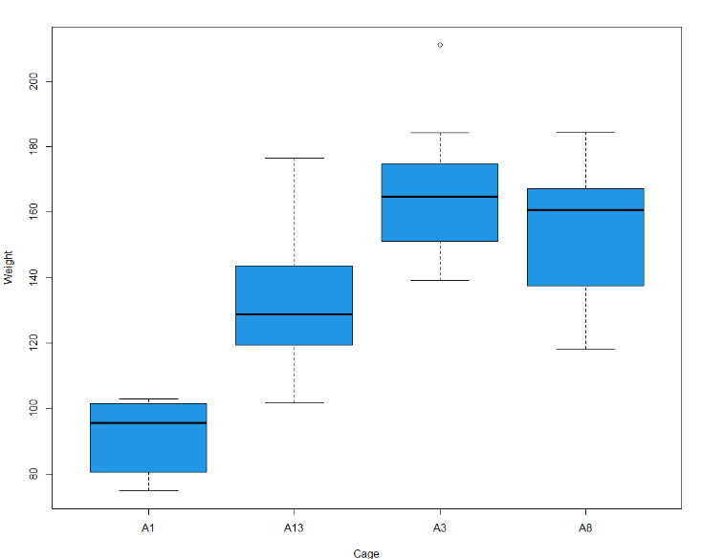Figure 2: Boxplot for Weight in T0 (control and treatment 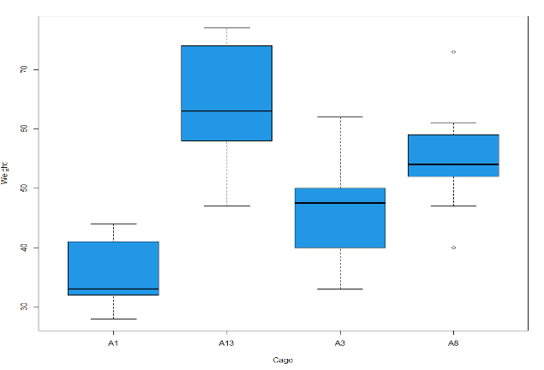)

Figure 3: Boxplot for Weight in T90 (control and treatment)

**Length gain**

Table 4: Length gain per cage of European seabass (*Dicentrarchus labrax*) for control and treatment

|  |  |  |  |  |
| --- | --- | --- | --- | --- |
|  | A1 | A3 | A8 | A13 |
| Initial length(cm) | 14.35±0.15 | 15.1±0.33 | 16.4±0.32 | 17±0.27 |
| Final length(cm) | 19.9 ± 0.23 | 22.23±0.33 | 23.32±0.27 | 23.59±0.34 |
| Length gain(cm) | 5.55 | 7.13 | 6.92 | 6.59 |
| Percentage length gain | 38.68 | 47.22 | 42.19 | 38.76 |

In the Table 2 above, the initial mean length represents the length of the experimental fish for T0 while the final mean length represents the length of the experimental fish in T90. The initial mean length per cage for cage A1, A3, A8 and A13 are 14.35±0.15cm, 15.1±0.33cm, 16.4±0.32cm and 17±0.27cm respectively. The final mean lengths for A1, A3, A8 and A13 are 19.9 ± 0.23cm, 22.23±0.33cm, 23.32±0.27cm and 23.59±0.34cm. Result of the percentage length gain shows that A3 pooled highest at 47.22%, this was followed by cage A8 (42.19%), A13 (38.76%) and A1 (38.68%). The length gain for fish in the ultrasound cage was 6.86cm while the length gain for fish in the control cage was 6.24cm. For length per cage, A3 has the highest length gain (7.13cm), this was followed by A8 (6.92cm), A13(6.59cm) and A1 (5.55cm) respectively.

From the boxplot below (figure 4) for T0, the means of the lengths are unequal. The highest mean length is found in A13 and A8 while the minimum mean length is found in cage A3. In T90, the mean length of all the cages are unequal but shows a consistent length distribution per cage. The highest mean length range was found in cage A8, and the lowest mean range is found in cage A1. An ANOVA test showed that there is sufficient evidence to say that the mean length of the cages is not equal (p<0.05). However, a posthoc Tukey test revealed similarities between A3 and A1, and between A8-A13. In the ANOVA test for T0, there is sufficient evidence to say that the mean length of the cages is not equal (p<0.05). A post-hoc Tukey test revealed similarities between A3 and A1, and between A8-A13.

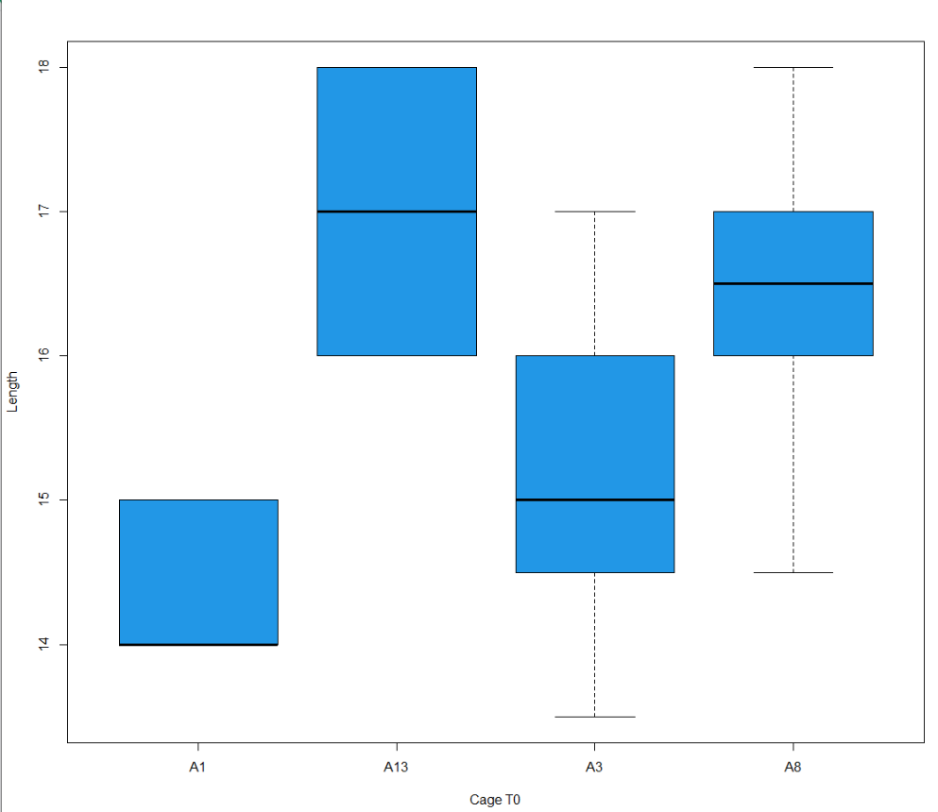

Figure 4: Boxplot for Length in T0 (control and treatment)

Figure 5: Boxplot for Length in T90 (control and treatment 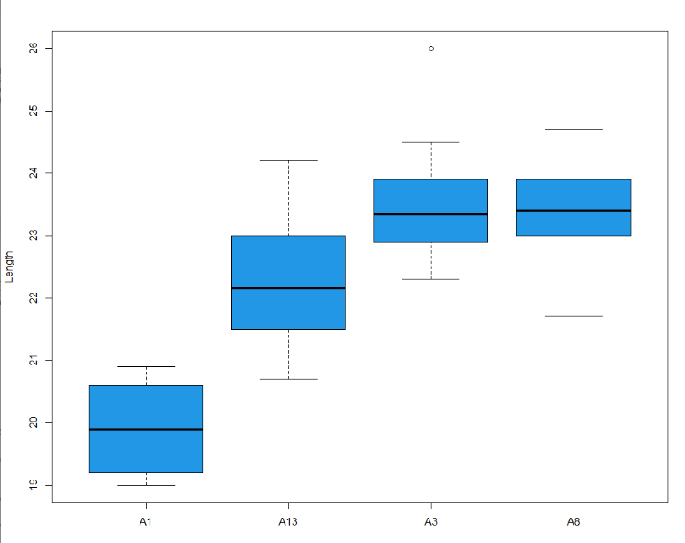)

**Specific growth rate (SGR):** The values of the specific growth rate of the Seabass were observed as 1.12 for the control and 1.12 for the treatment. Per cage (figure 6), the values are 1.08, 1.18, 1.07 and 1.14 for cage A1, A3, A13 and A8 respectively. The highest specific growth rate was observed in A3 while the lowest specific growth rate was found in in cage A13.

Figure 6: SGR line graph of treatment cages

**Hepasomatic index (HSI):**

|  |  |  |  |  |
| --- | --- | --- | --- | --- |
|  | A1 | A3 | A8 | A13 |
| Initial HSI | 4.55±0.46 | 3.59±0.15 | 3.75±0.28 | 3.06±0.21 |
| Final HSI | 2.47±0.20 | 2.63±0.14 | 2.47±0.15 | 3.08±0.21 |

This parameter is used to measure the energy reserves of the fish. The mean values for the HSI for control and treatment were calculated as 2.49 and 2.89 for control and treatment respectively. On the per cage basis, The T0 values for HSI were higher than the T90 mean values except for cage A13. The T0 values are 4.55±0.46, 3.59±0.15, 3.75±0.28 and 3.06±0.21 for A1, A3, A8 and A13 respectively. For T90, the HSI values were 2.47±0.20, 2.63±0.14, 2.47±0.15 and 3.08±0.21 for A1, A3, A8 and A13 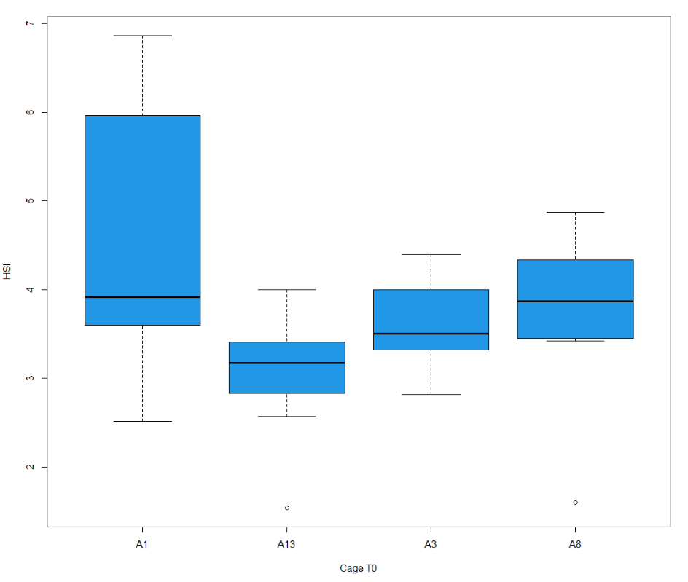respectively.

**Figure 7**: Boxplot for HSI in T0 (control and treatment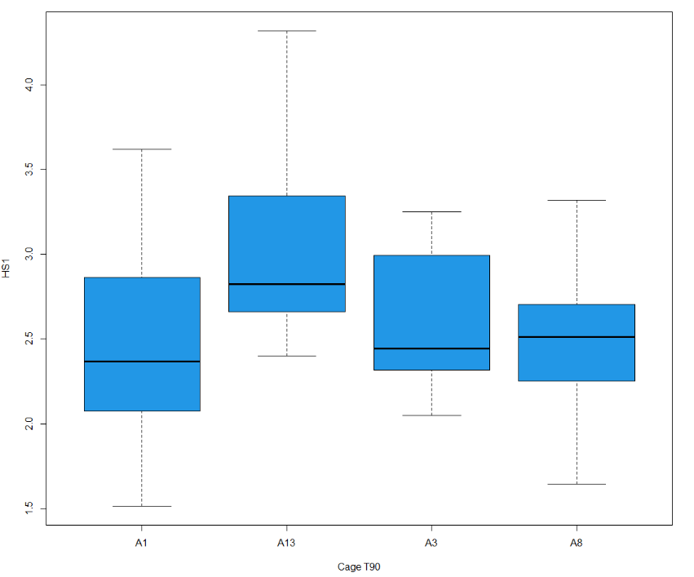)

**Figure 8**: Boxplot for HSI in T0 (control and treatment)

From the boxplot below (figure 7) for T0, the mean length of all the cages are unequal in the distribution per cage. The highest mean length range was found in cage A1, and the lowest mean range is found in cage A1. For T90, the highest mean range was found in A13 while the lowest range was found in A1.

**Analysis of stress response to Ultrasound**

Cortisol, lactate, Glucose and other ions are widely used as stress markers for fish which allows scientist to draw valuable conclusion on the extent of environmental and physical stress experienced by the fish. Values are represented as mean ± S.E.M. The stress response represented includes cortisol, lactate, glucose, Na+, K+, and Cl-.

**Table 3: Mean values of different stress response of the European Seabass in T0**

|  |  |  |  |  |
| --- | --- | --- | --- | --- |
|  | **A1** | **A3** | **A8** | **A13** |
| Cortisol (nmol/L) | 132.48±34.86 | 223.42±36.38 | 240.86±22.50 | 223.5±31.41 |
| Lactate (mmol/L) | 4.42±0.84 | 9.12±1.48 | 6.66±1.58 | 4.48±0.53 |
| Glucose (mg/dl) | 155.8±41.13 | 110±14.99 | 236±25.99 | 147.9±21.65 |
| Na+ (mmol/L) | 111±23.61 | 158.4±15.68 | 171.8±5.42 | 144.5±2.59 |
| K+ (mmol/L) | 8.75±1.45 | 7.76±0.76 | 7.72±0.44 | 5.65±0.66 |
| Cl (mmol/L) | 86.8±18.12 | 126.6±13.51 | 140.1±2.66 | 123.8±2.40 |

**Table 4: Mean values of different stress response of the European Seabass in T90**

|  |  |  |  |  |
| --- | --- | --- | --- | --- |
|  | **A1** | **A3** | **A8** | **A13** |
| Cortisol (nmol/L) | 273.08±32.05 | 387.78±11.04 | 344.26±42.98 | 409.8±6.59 |
| Lactate (mmol/L) | 9.78±0.38 | 10.62±1.28 | 11.84±1.32 | 15.62±1.19 |
| Glucose (mg/dl) | 165.5±9.12 | 302.7±24.51 | 364.8±28.08 | 569.78±25.70 |
| Na+ (mmol/L) | 187.2±8.72 | 198.9±4.04 | 195.3±3.57 | 187.2±4.43 |
| K + (mmol/L) | 5.4±8.72 | 5.84±0.19 | 5.7±0.25 | 5.91±0.25 |
| Cl- (mmol/L) | 159.7±8.43 | 155.7±2.74 | 153±2.65 | 142.4±3.06 |

**Cortisol stress response:**

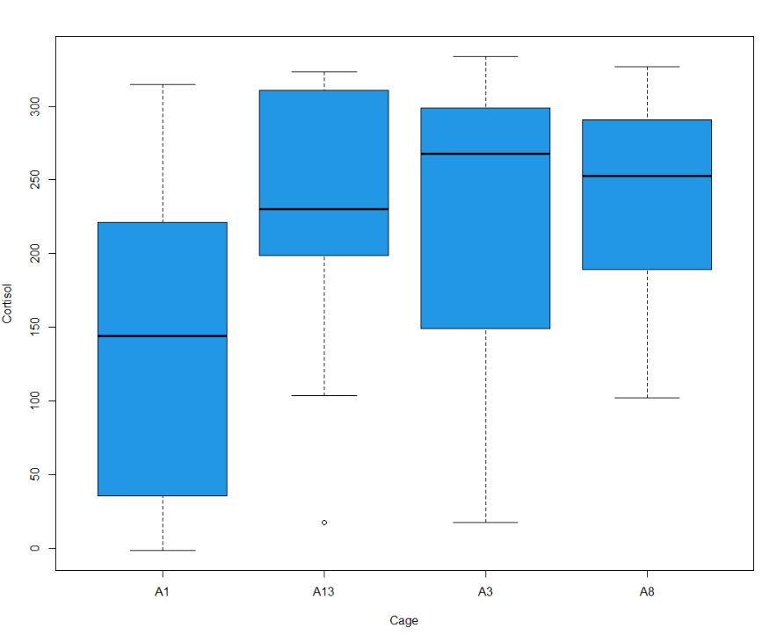In the table above, the plasma cortisol per cage for T0 pooled 132.48±34.86 nmol/L, 223.42±36.38 nmol/L, 223.42±36.38nmol/L and 240.86±22.50nmol/L for A1, A3, A13 and A8 respectively. The values of A1 ranged from -1.601 to 361.66nmol/L, A3 values ranged from 17.31 to 428.24 nmol/L, A13 values ranged from 17.30 to 435.31 nmol/L while A8 range 74.31 to 454.85nmol/L. The plasma cortisol concentrations are represented as boxplots in figure 7 and figure 8 for T0 and T90 respectively. The European seabass (*Dicentrarchus labrax)* fish in all the cages showed an elevated level of cortisol. For T0, the highest mean range is found in Cage A3 while Cage A1 has the lowest mean range. When subjected under the ANOVA test, there was sufficient evidence to state that the mean levels of cortisol in the cages are equal (p>0.05). In the T90 boxplot, there is low variability of data in the cages and the means are unequal. The highest mean range was found in Cage A8 while Cage A1 has the lowest mean range. When subjected to ANOVA test, there was sufficient evidence to say that the mean cortisol levels of the cages are not equal (p<0.05). A posthoc Tukey test revealed that there is a significant difference between all the cages except in A13-A1 and A3-A1.

**Figure 7**: Boxplot for cortisol in T0 (control and treatment)

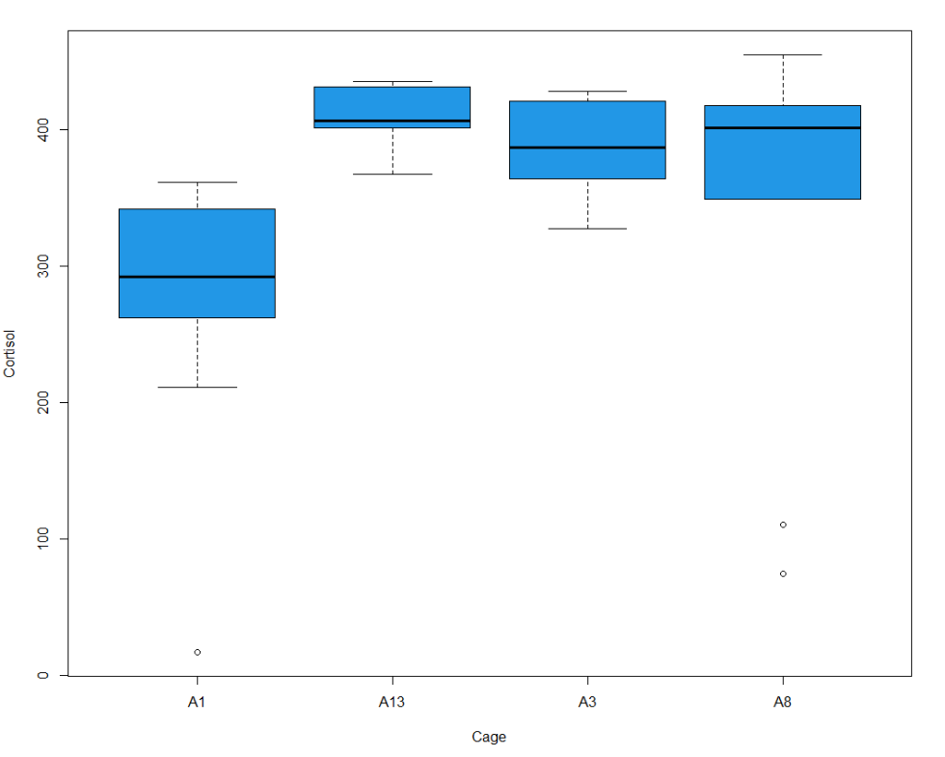**Figure 8**: Boxplot for cortisol in T90 (control and treatment)

**Lactate**

In the table 3 above, the mean values of lactate per cage for T0 are 4.42±0.84mmol/L, 9.12±1.48mmol/L, 6.66±1.58mmol/L, and 4.48±0.53mmol/L for cage A1, A3, A8 and A13. Also, lactate concentrations for cages in T90 pooled higher than the T0 concentrations, the mean lactate values are 9.78±0.38mmol/L, 10.62±1.28mmol/L, 11.84±1.32mmol/L and 15.62±1.19mmol/L for A1, A3, A8 and A13 in that order.

Analysis of blood lactate in figure 9 showed a huge variation in lactate in cage A3 than any other cage in T0. The highest mean range for lactate in T0 was found in Cage A3 while the lowest mean range is found in cage A1. For T90 boxplot found in figure 9, the means of the cages are visually not equal while the means are more consistent in cage A1 and A13. The highest mean range is found in cage A3 and the lowest mean range is found in cage A13. There was sufficient evidence to say that the mean lactate of T0 cages are not equal (P<0.05). Multiple comparison of means using Tukey test reveals that the cages were only statistically different between cages A8-A3. There was no significant 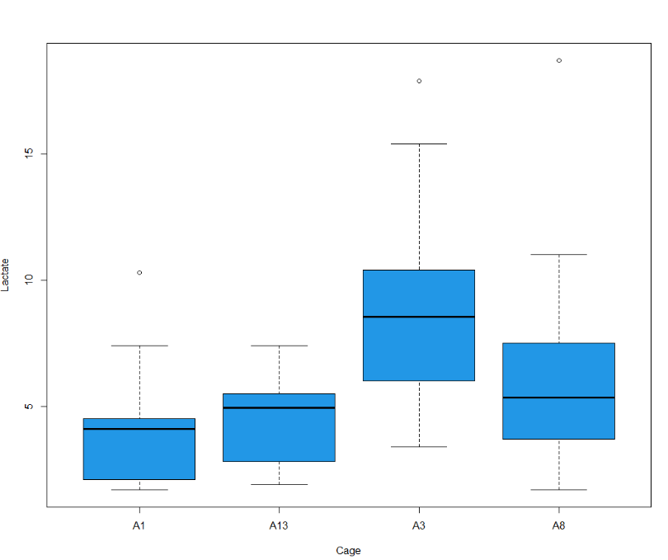difference between the others.

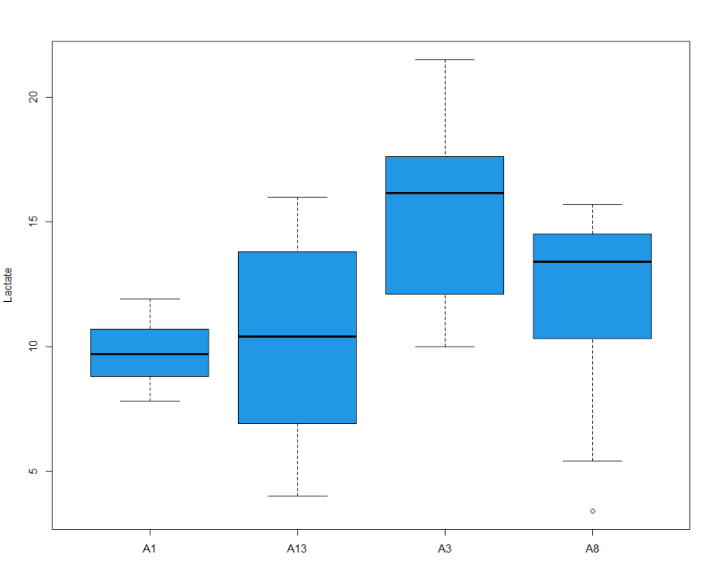Figure 9: Boxplot for lactate in T0 (control and treatment)

**Figure10**: Boxplot for lactate in T90 (control and treatment)

**Glucose**

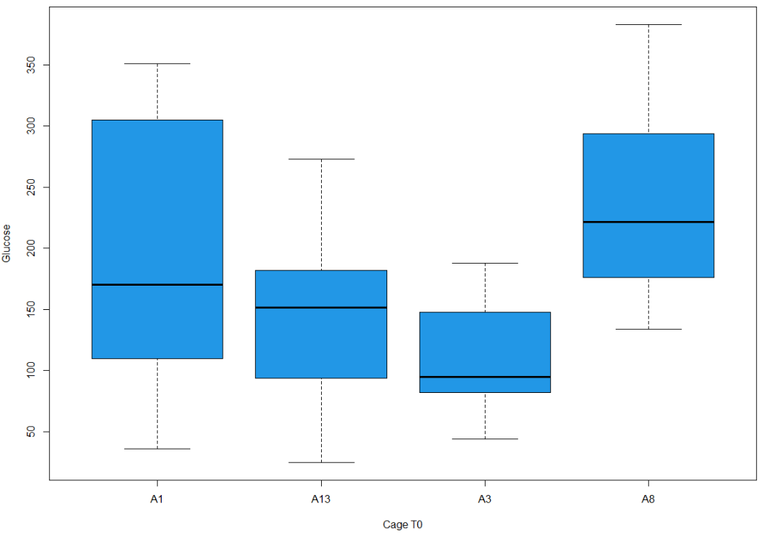The mean blood glucose per cage for T0 are 155.8±41.13mg/dl, 110±14.99mg/dl, 236±25.99mg/dl and 147.9±21.65mg/dl for A1, A3, A8 and A13 respectively. Also, glucose concentrations for cages in T90 were higher than the T0 concentrations. T90 concentrations were 165.5±9.12mg/dl, 302.7±24.51mg/dl, 364.8±28.08mg/dl and 569.78±25.70mg/dl for A1, A3, A8 and A13 respectively. In the boxplot (figure 11), the highest mean range for glucose in T0 was found in Cage A8 while the lowest mean range is found in cage A13. For T90 boxplot (figure 12), the means of the cages are visually not equal while the means are more consistent in cage A1 and A3. The highest mean range is found in cage A13 and the lowest mean range is found in cage A1. There was sufficient evidence to say that the mean glucose of T0 and T90 cages are not equal (P<0.05). A post-hoc Tukey test revealed that there is a significant difference between A8 and A3 in T0 and but all combinations in T90 were statistically different except between A8 and A3 for T90.

**Figure 11**: Boxplot for Glucose in T0 (control and treatment)

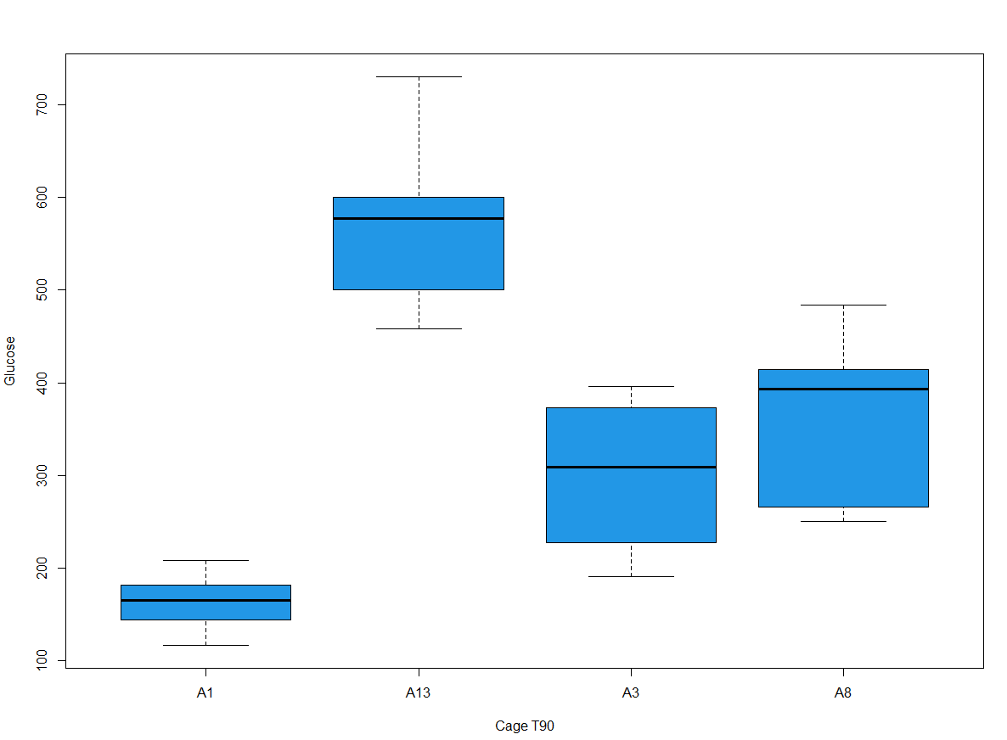**Figure 12**: Boxplot for Glucose in T90 (control and treatment)

**NA:** The mean Na per cage for T0 are 111±23.61mmol/L, 158.4±15.68mmol/L, 171.8±5.42mmol/L and 144.5±2.59mmol/L for cage A1, A3, A8 and A13. Higher values were experienced in all cages of the T90 than in T0. The T90 mean Na values per cage are 187.2±8.72mmol/L, 198.9±4.04mmol/L, 195.3±3.57mmol/L, 187.2±4.43mmol/L.

**K:** The mean K values per cage for T0 are 8.75±1.45mmol/L, 7.76±0.76mmol/L, 7.72±0.44mmol/L and 5.65±0.66mmol/L for cage A1, A3, A8 and A13 respectively while 5.4±8.72mmol/L, 5.84±0.19mmol/L, 5.7±0.25mmol/L and 5.91±0.25mmol/L are mean values for T90 for cages A1, A3, A8 and A13.

**Cl**: The mean values of Cl per cage for T0 are 86.8±18.12, 126.6±13.51, 140.1±2.66 and 123.8±2.40 for cage A1, A3, A8 and A13 respectively. The T90 group pooled higher mean values than the T0. The values are 159.7±8.43mmol/L, 155.7±2.74mmol/L, 153±2.65mmol/L and 142.4±3.06mmol/L for cages A1, A3, A8 and A13.

Figure 13: Bar chart for mean values of Na, K and Cl per cage

**Blood parameters**

The mean blood counts for T0 and T90 fish are presented in Table … This complete blood count is necessary as it helps to monitor the health status of the fish especially their response to therapy, disease, change in nutrition or stress. Values are represented as mean ± S.E.M. The blood parameters presented includes RBC, WBC and thrombocytes.

Table 5: Mean counts for blood parameters for T0

|  |  |  |  |  |
| --- | --- | --- | --- | --- |
|  | **A1** | **A3** | **A8** | **A13** |
| **RBC** (millions/uL) | 749.90±44.95 | 991.35±63.60 | 951.65±74.37 | 1014.25±48.40 |
| **WBC** (K/uL) | 47.7±6.76 | 104.51±18.33 | 54.05±6.05 | 44.68±6.66 |
| **Thrombocytes(**mcL) | 1.7±0.56 | 22.24±3.47 | 11.51±1.67 | 12.87±7.27 |

Table 6: Mean counts for blood parameters for T90

|  |  |  |  |  |
| --- | --- | --- | --- | --- |
|  | **A1** | **A3** | **A8** | **A13** |
| **RBC** (millions/uL) | 749.90±44.95 | 991.35±63.60 | 951.65±74.37 | 1014.25±48.40 |
| **WBC** (K/uL) | 47.7±6.76 | 104.51±18.33 | 54.05±6.05 | 44.68±6.66 |
| **Thrombocytes(**mcL) | 1.7±0.56 | 22.24±3.47 | 11.51±1.67 | 12.87±7.27 |

**RBC:** The mean red blood cell count per cage for T0 are 749.90±44.95millions/uL, 991.35±63.60millions/uL, 951.65±74.37millions/uL and 1014.25±48.40millions/uL for A1, A3, A8 and A13 respectively. Also, mean RBC counts for T90 were 749.90±44.95millions/uL, 991.35±63.60 millions/uL, 951.65±74.37millions/uL and 1014.25±48.40millions/uL for A1, A3, A8 and A13. In the box plot below (figure 14) for T0, there is a high variability of data in cage A3 and A8. The highest mean range is found in cage A3 while Cage A1 has the lowest mean range. In the T90 boxplot (figure 15), there is a high variability of data in Cage A1, A3 and A8. Its highest mean range is found in cage A3 while Cage A1 has the lowest mean range. An ANOVA test for T0 showed sufficient evidence to say that the mean RBC of the fishes per cage are not equal (P<0.05). A posthoc test reveals that the significant difference lies only in cages A13-A1 and A3-A1. In the T90, there was sufficient evidence to say that the mean RBC of the fishes per cage are not equal (P<0.05). A post-hoc Tukey test reveals a significant difference between all the cages A3-A1.

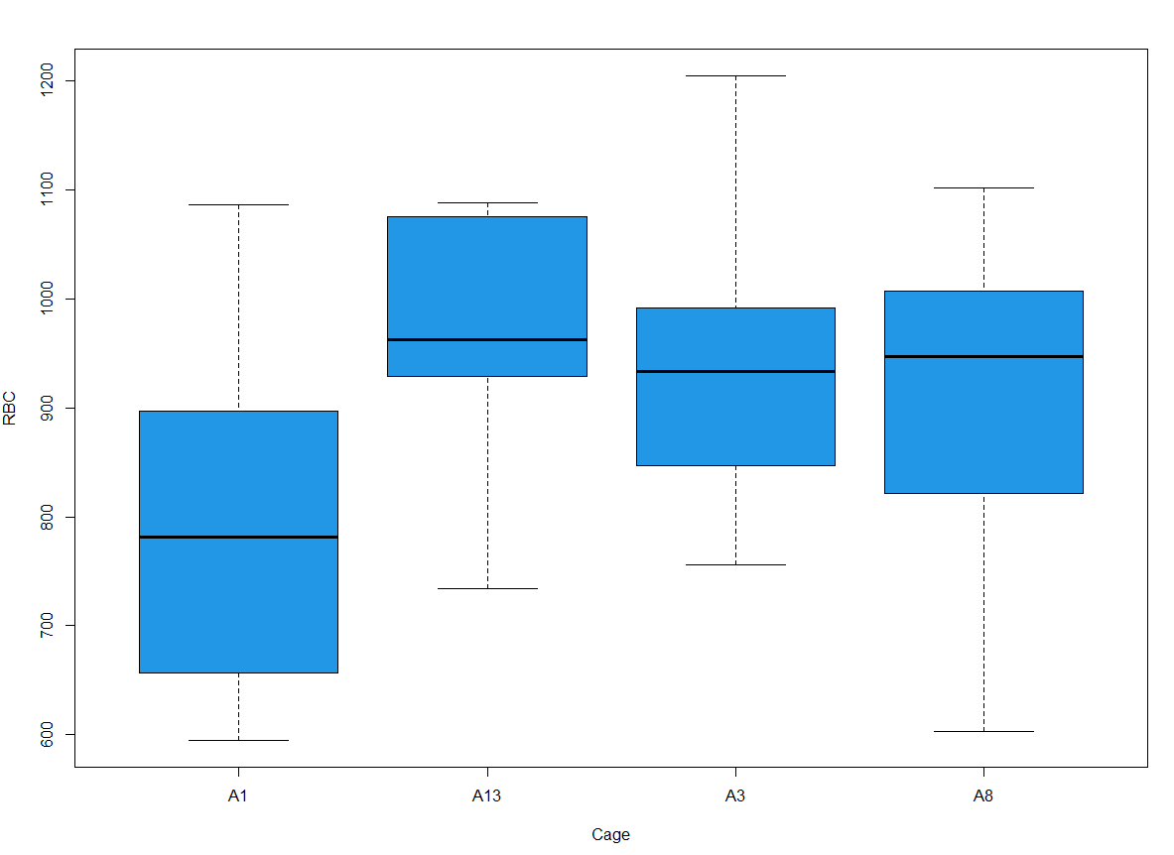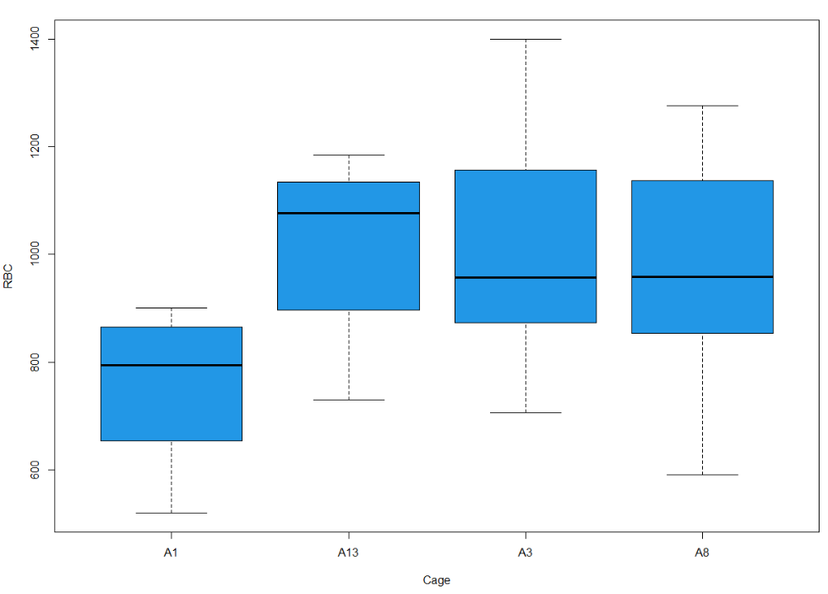**Figure 14**: Boxplot for RBC in T0 (control and treatment)

**Figure 15**: Boxplot for RBC in T90 (control and treatment)

**WBC:** The mean WBC concentrations for T0 per cage were 47.7±6.76K/uL, 104.51±18.33K/uL, 54.05±6.05K/uL and 44.68±6.66K/uL for cages A1, A3, A8 and A13 respectively. Also, WBC concentrations in T90 pooled higher than T0 and ranged from 47.7±6.76K/uL, 104.51±18.33K/uL, 54.05±6.05K/uL and 44.68±6.66K/uL for cages A1, A3, A8 and A13. Boxplots analysis (figure 16) shows a huge variation in WBC in cage A3 more than in other cages in T0. The highest mean range for WBC in T0 is found in cage A3 while the lowest mean range is found in cage A13. For T90 (Figure 17), the means of the cages are unequal while huge variations can be seen in cage A13. Also, cage A13 has the highest mean range and also pooled the lowest mean range in the four cages assessed. There was sufficient evidence to say that the mean WBC of T0 cages are not equal (P<0.05). Multiple comparison of means using Tukey test reveals that the cages were statistically different between cages A13-A1 and A3-A1. There was no significant difference between the others. In T90, sufficient evidence also to say that the mean WBC in T90 cages are not equal (P<0.05). A post-hoc Tukey test revealed cages A13-A1 to be significantly different.

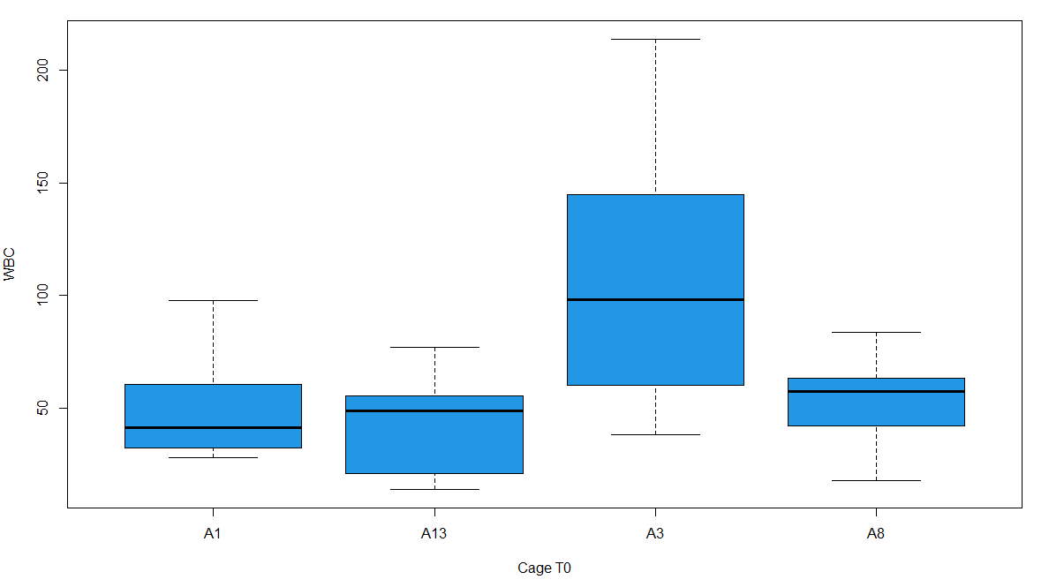

**Figure 16**: Boxplot for WBC in T0 (control and treatment)

**Figure 17**: Boxplot for WBC in T90 (control and treatment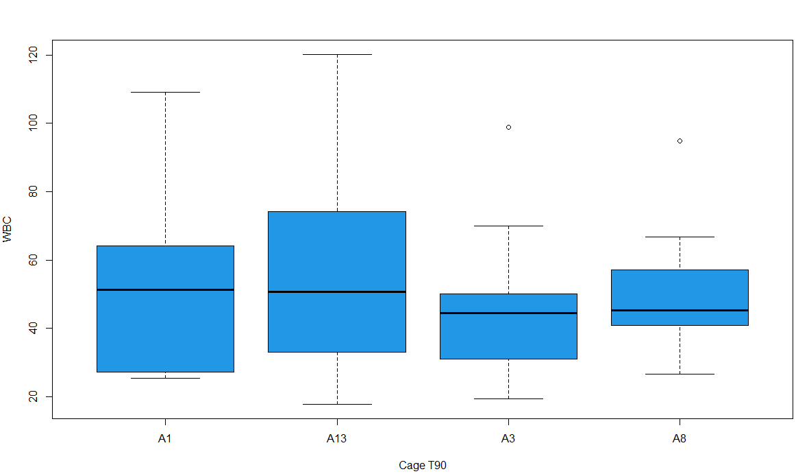)

**THROMBOCYTES:** The mean thrombocytes’ concentrations for T0 were 1.7±0.56mcL, 22.24±3.47mcL, 11.51±1.67mcL and 12.87±7.27mcL for cages A1, A3, A8 and A13 respectively. Also, WBC concentrations in T90 pooled higher than T0 and ranged from 1.7±0.56mcL, 22.24±3.47mcL, 11.51±1.67mcL and 12.87±7.27mcL for cages A1, A3, A8 and A13.

Boxplots analysis (figure 18) shows a bigger variation in thrombocytes in cage A3 more than in other cages in T0. The highest mean range for thrombocytes in T0 is found in cage A3 while the lowest mean range is found in cage A1. For T90 (figure 19), the means of the cages are unequal while huge variations can be seen in cage A3. Also, cage A3 has the highest mean range and while cage A8 pooled the lowest mean range in the four cages assessed. There was sufficient evidence to say that the mean WBC of T0 cages are not equal (P<0.05). Multiple comparison of means using Tukey test reveals that the cages were statistically different between cages A3-A1. There was no significant difference between the others. In T90, sufficient evidence also to say that the mean thrombocytes in T90 cages are not equal (P<0.05). A post-hoc Tukey test revealed cages A13-A1, A8-A1, A3-A13, and A8-A3 to be significantly different.

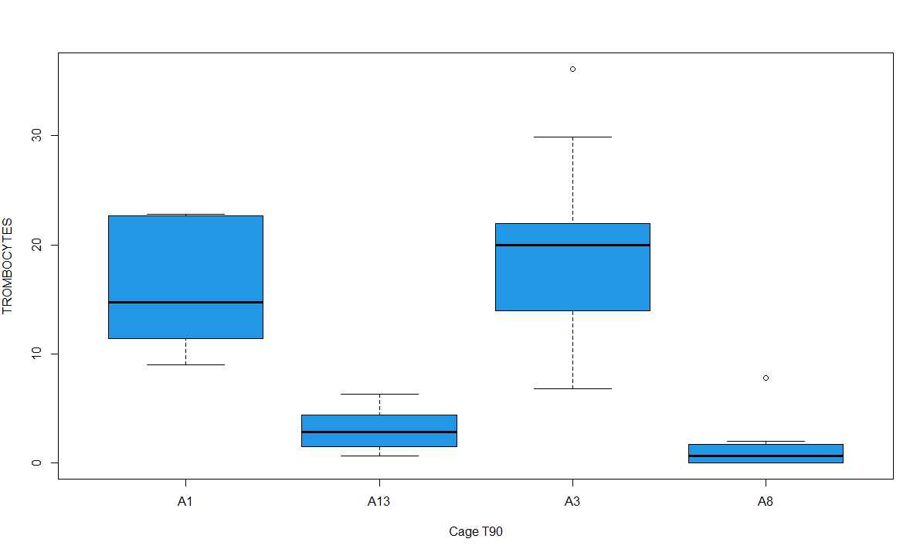**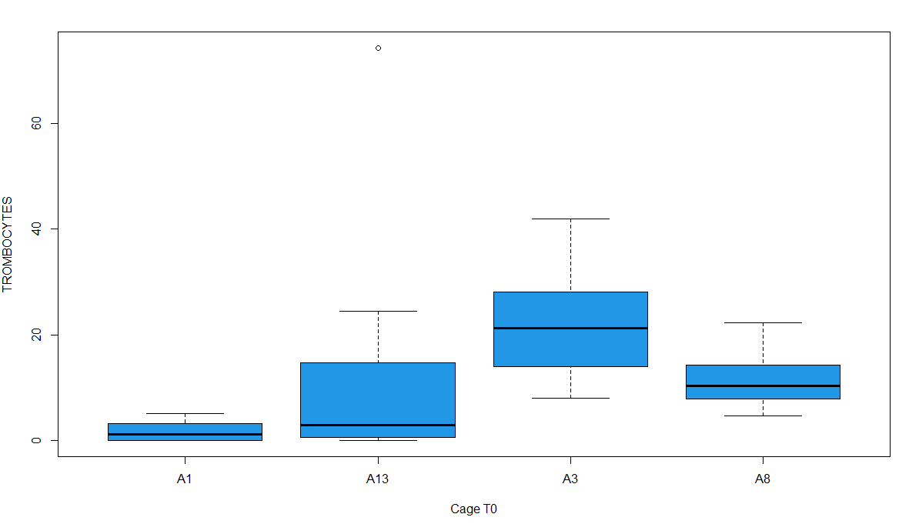Figure 18**: Boxplot for thrombocytes in T0 (control and treatment)

**Figure 19**: Boxplot for thrombocytes in T90 (control and treatment)

**Multiple Linear relationship between stress variables and growth parameters**

This researched used the multiple linear regression to decipher the influence of length and weight on the outcome of individual stress parameters per cage and time. This enabled us to determine the relative contribution of the length and weight to the total variance. The result of the multi-linear regression is presented in appendix 1 and appendix 2.

Result showed that Weight and length of fish does not have any influence on the depedent parameters (Lactate, glucose, cortisol, RBC, WBC, thrombocyte, K+ , Na+ and Cl- for T0 (control and treatment cages) (P>0.05). However, there was a significant influence of weight on the values of RBC and length on the values of thrombocytes (P<0.05) in T90 for the control cages. Also, weight and length influenced significantly the values of Na (P<0.05) for the treatment cages of T90.

Correlation analysis was used to discover if there are relationships between the stress paramenters and the independent variables of weight and length. Results show that in the control experiment for T0, weight has a strong positive correlation with length, RBC and trombocytes and has a weak positive correlation with lactate and WBC. It also has a negative correlation with HSI. In the treatment cages of T0, there was a strong positive correlationn between weight and length only but has a weak positive correlation with glucose and RBC. It also has a weak negative correalation with lactate, K+, WBC, trombocytes and cortisol but strongly correlated with HSI on the negative scale. Other results are seen in appendix 3 and apendix 4.

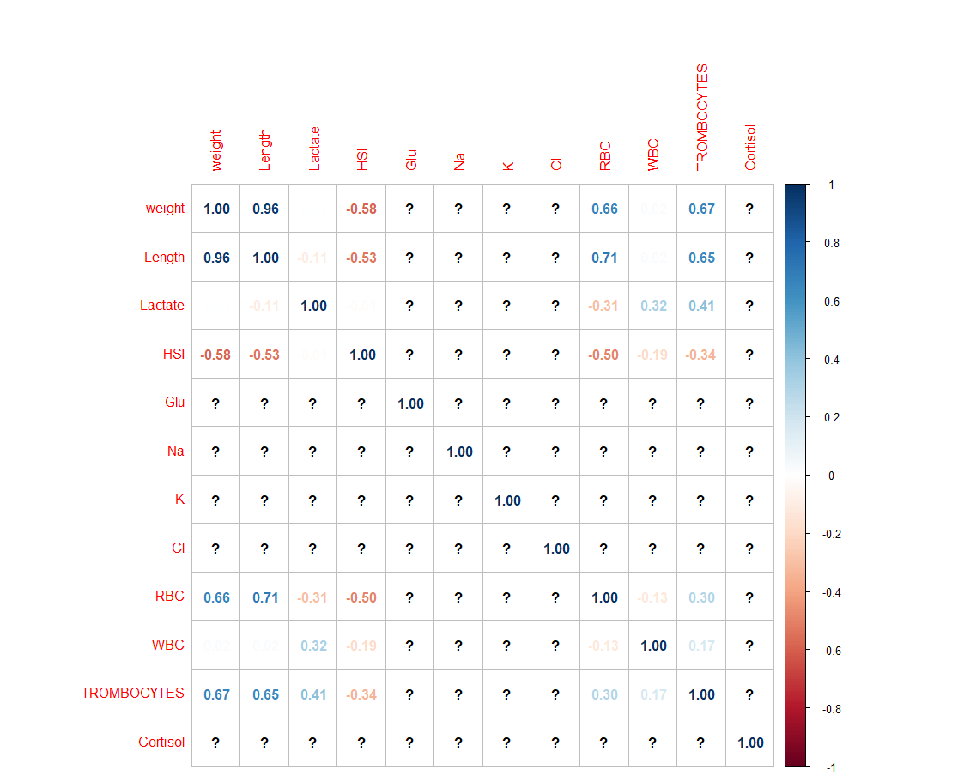

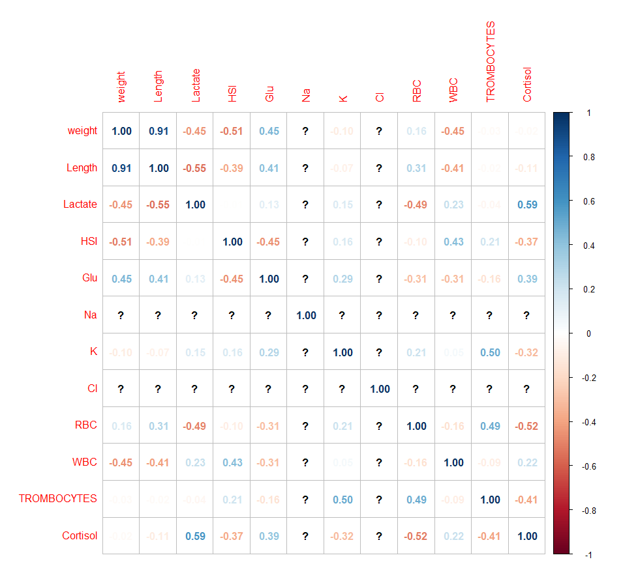Figure 20: multiple correlation co-efficient plot for T0 (control)

Figure 21: multiple correlation co-efficient plot for T0 (ultrasound)

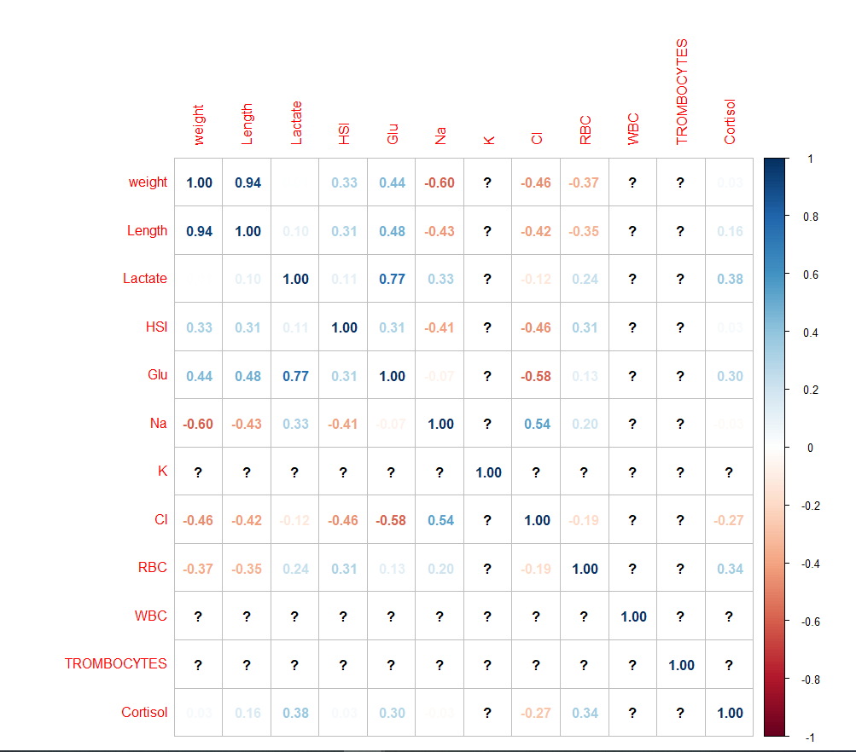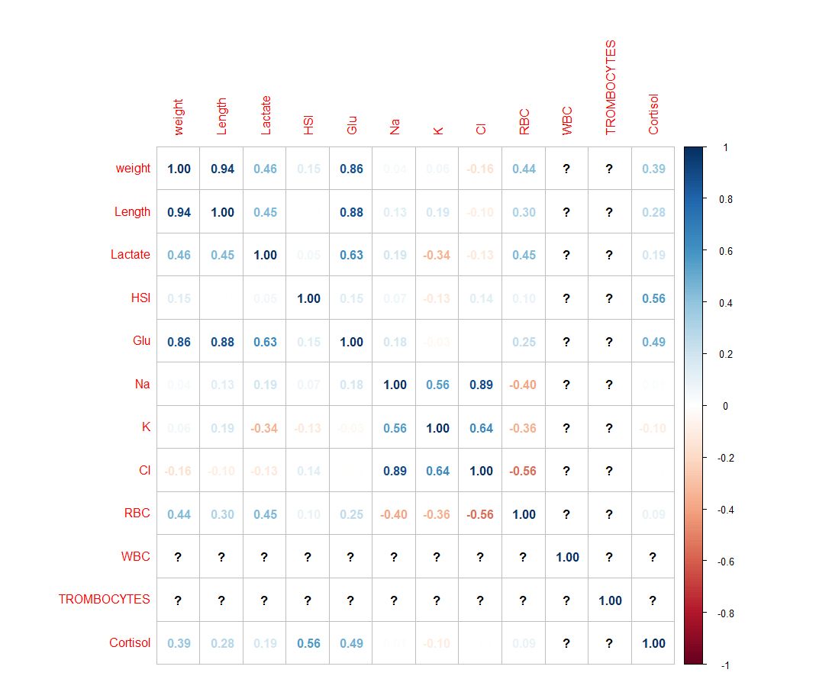Figure 22: multiple correlation co-efficient plot for T90 (control)

Figure 23: multiple correlation co-efficient plot for T90 (ultrasound)

**Gill histopathology result:**

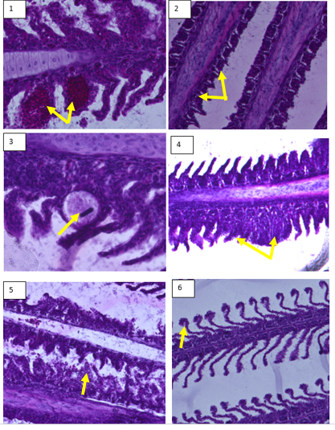The histopathology evaluations of the gills involves the examination of the photomicrographs and identification of alterations(if any) found in the fish’s gills for both control and treatment. Most histopathological biomarkers are directly related to the stress biomarkers of stress (Subburaj et al. 2017). The study identified the presence of aneurism, shortened lamellae, parasitic cyst, lamellae fusion, epithelial rupture, necrosis, vascular congestion and vasodilation. The photomicrographs exposed gill and control are described below:

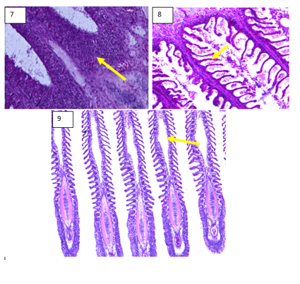

**Figure 22:** The histology section of the gills for both control and treatment cages showing the following defects (1) Aneurism (2) Shortened lamellae (3) Parasitic cyst (4) Fusion of the lamellae (5) Epithelial rupture (6) Curling of the lamellae (7) Leukocyte infiltration (8) Necrosis of the gills (9) Vascular congestion (10) Vasodilation

Table 6: The histological changes in the gills of the European seabass reared in a offshore cage for both control and treatment

|  |  |  |  |  |
| --- | --- | --- | --- | --- |
| Histological changes | T0 | | T90 | |
| Control (%) | Treatment (%) | Control (%) | Treatment (%) |
| Aneurism | 50 | 60 | 70 | 50 |
| Shortened lamellae | 70 | 60 | 80 | 50 |
| Parasitic cyst | 20 | 20 | 30 | 10 |
| Fusion of the lamellae | 90 | 90 | 80 | 90 |
| Epithelial rupture | 90 | 100 | 100 | 100 |
| Curling of the lamellae | 50 | 80 | 60 | 60 |
| Leukocyte infiltration | 30 | 10 | 10 | 0 |
| Necrosis of the gills | 70 | 80 | 80 | 60 |
| Vascular congestion | 0 | 10 | 20 | 10 |
| Vasodilation | 30 | 30 | 30 | 10 |

**Legends**: AN = aneurism, SL= Shortened lamellae, PC= parasitic cyst, FL= fusion of the lamellae, ER = epithelial rupture, CL= curling of the lamellae, LI= leukocyte infiltration, NA= necrotic areas, VC = vascular Congestion, VS = Vasodilation

**Figure 23**: Barchart showing number of defects in gill histopathology for treatment and control

In the graph above (figure 23), epithelial rupture has the highest occurrence in both the control and treatment groups. This was closely followed by Lamellae fusion and the presence of necrotic areas. However, vascular congestion and leukocyte infiltration has the lowest counts of the defects examined. Upon subjecting the data to a chi-square analysis (p>0.05), it was found that the variables are independent and there is no relationship between treatment and control. The detailed results are given below;

**Aneurysm:** This severe irreversible damage can be characterized by the leakage of blood in the lamellae and the dilation of the blood vessels (Martinez *et al.*, 2004). 50% of the gill samples examined in T0 has changes related to aneurysm in the control experiment while 60% have this changes in the treatment ponds. In T90, aneurysm was present in 70% of the examined gill slides for control while 50% was seen in the treatment.

**Shortened lamellae**: This defect has different infectious and non-infectious causes and is the most common response of gill damage. They can be caused by genetics, thermal shock, ammonia toxicity and strong water current ( Gulhan et al. 2014). In our result, 70% of the gill slides had shortened lamellae in the control group of T0 while 60% of the slides in the treatment had shortened lamellae. In the T90, 80 % of the gill slides showed the presence of shortened lamellae in the control while only 50% is present in the treatment cages.

**Parasitic cyst:** Many parasite found in fish body are etiological agents which can damage the gills of the fish when there is an imbalance in the host-parasite-environment relationship. In the T0, 20% of the examined gill slides in control have parasitic aletration in the gill structure while these alterations seen equally in the treatment at 20%. In the T90, 30% of these parasitic alteration was seen in the examined gill slide for the control experiment while there was only 10% alterations in the treatment.

**Fusion of the lamellae**: severe hyperplasia can lead to the total or partial fusion of the lamellar of fish gills (Sollid and Nilsson, 2006). Results show that this defect was present in T0 at 90% for both treatment and control and at 80% and 90% for treatment and control in T90.

**Epithelial lifting**: to avoid the entry of xenobiotics, the lamella epithelial layers separate leading to an increase in the intracellular spaces between the pillar system and the lining of the secondary lamellae (Gulhan et al. 2014). Based on the result, 90% of the observed gill slide had epithelial lifting in the control group of T0 while the treatment grup had 100%. In the T90, the gill slides all that epithelial lifting (100%) for both control and treatment.

**Curling of the lamellae**: Curling of the secondary lamellae was observed in 50% of the gill slides in the control group of T0 while 80% of the treament group had this defect. Also , there were 60% presence of this defect in the control and treatment group of T90.

**Leukocyte infiltration**: The study observed 30% of the examined slides as infiltrated by leukocytes in the control group of T0 and only 10% in the treatment group. Also, 10% was observed in the control group of T90 while there was no infiltration of the treatment group in the observed slides.

**Necrotic areas**: Typical of a degenrative process and are observed when the fish gill is exposed to toxins (Rogers, 2007). These irreversible histological changes were observed in 70% of the observed slides in the control group of T0 and 80% in the treatment group. In the T90, 80% of the control group had necrotic areas while 60% can be seen in the treatment groups.

**Vascular congestion**: Also known as lamellar blood congestion which can impair the gas-exchange in gills (Strzyżewska *et al.*, 2016). This impairment was absent in the control group of the T0 and only present in 10% of the treatment group. In the T90, it was found in 20% of the control and 10% of the treatment group.

**Vasodilation**: This was found in 30% of both the treatment and control of the T0 group. Also, 30% of the control group of the T90 has vasodilation while the treatment group has 10%.